Facile Carbonyl Sulfide (COS) Fixation into Novel COS-Storage Materials Towards Preparation of CdS Photocatalyst for CO2 Reduction and Promotion of Plant Growth
Bin Li^{1,2}, Tingyu Yang^{2,3}, Xiaoqing Yue^{2,4}, Jianbin Zhang^{1,2}*
1 Hebei Provincial Key Lab of Green Chemical Technology and High Efficient Energy Saving, School of Chemical Engineering and Technology, Hebei University of Technology, Tianjin, 300130, China
2 Inner Mongolia Engineering Research Center for CO₂ Capture and Utilization, Hohhot, 010051, China
3 College of Life and Environmental Science, Minzu University of China, Beijing, 100081, China
4 Materials Science and Engineering, Harbin Institute of Technology, Heilongjiang, 150001, China
*To whom correspondence should be addressed. E-mail: tadzhang@pku.edu.cn (J. Zhang)

Supporting Information
Materials
Cadmium nitrate was obtained from Tianjin Fengchuan Chemical Reagent Technology Co., Ltd. and analytical grade NH₄HCO₃ was bought from Tianjin Reagent Company (Tianjin, China). 99.9% COS used in the experiment was purchased from Shenzhen Jingu Gas Co., Ltd., China. The four plants used in this experiment were eggplant, tomato, pepper and cucumber. The plants were transplanted into flowerpots of 36 cm × 24 cm. And the soil came from the same place. Simultaneously, the same kind seedlings were purchased from the market. The chemical reagents used in the experiment are listed in Table S1.
Characterizations of COSSMs
The COSSMs were firstly characterized by Fourier transform infrared spectroscopy (FTIR), nuclear magnetic resonance (¹³C-NMR), X-ray photoelectron spectroscopy (XPS) and X-ray diffraction (XRD). The models, specifications and manufacturers of various types of instruments are shown in Table S2.

Table captions
Table S1 Specification of chemical samples.
Table S2 The models, specifications and manufacturers of various types of instruments.
Table S3 The average growth of pepper at 30 d, 60d.
Table S4 The average growth of eggplant at 30 d, 60d.
Table S5 The average growth of tomato at 30 d, 60d.
Table S6 The average growth of cucumber at 30 d, 60d.
Table S7 Contrast results of eggplants blade at 30 d, 60d.
Table S8 Contrast results of cucumbers blade at 30 d, 60d.
Table S9 Contrast results of average stem diameters of pepper at 30 d, 60d.
Table S10 The average wet weight of 4 plants.
Table S11 The average dry weight of 4 plants.
Table S12 The ratio of dry to wet weight of 4 plants.
Table S13 Total nitrogen and pH in soil.

Table S1
Chemical name | Source | Initial mass fraction purity^{b} | Purification method
Ethylene glycol | Tianjin Yongsheng Fine Chemical Co., Ltd., China | ≥ 0.99 | Desiccation^{c} and degasification^{d}
Diethylene glycol | Tianjin Guangfu Fine Chemical Research Institute, China | ≥ 0.98 | Desiccation^{c} and  degasification^{d}
Triethylene glycol | Shanghai Macklin Fine Chemical, China | ≥ 0.99 | Desiccation^{c} and  degasification^{d}
Tetraethylene glycol | Shanghai Macklin Fine Chemical, China | ≥ 0.99 | Desiccation^{c} and  degasification^{d}
Polyethylene glycol 300 | Beijing Yili Fine Chemical Co., Ltd., China | ≥ 0.99 | Desiccation^{c} and  degasification^{d}
Polyethylene glycol 400 | Beijing Yili Fine Chemical Co., Ltd., China | ≥ 0.99 | Desiccation^{c} and  degasification^{d}
Dipropylene glycol | Shanghai Macklin Fine Chemical, China | ≥ 0.98 | Desiccation^{c} and  degasification^{d}
1,2-propanediol | Shanghai Macklin Fine Chemical, China | ≥ 0.99 | Desiccation^{c} and  degasification^{d}
1,3-butanediol | Shanghai Macklin Fine Chemical, China | ≥ 0.99 | Desiccation^{c} and  degasification^{d}
Ethylenediamine | Tianjin Fuyu Fine Chemical Co., Ltd., China | ≥ 0.99 | Desiccation^{c} and  degasification^{d}
1,3-propanediamine | Shanghai Titan Scientific Co., Ltd., China | ≥ 0.99 | Desiccation^{c} and  degasification^{d}
1,6-hexanediamine | Shanghai Macklin Fine Chemical, China | ≥ 0.99 | Desiccation^{c} and  degasification^{d}
Ethanol absolute | Tianjin Yongsheng Fine Chemical Co. Ltd., China | ≥ 0.995 | Desiccation^{c} and degasification^{d}
Triethanolamine | Tianjin Yongsheng Fine Chemical Co., Ltd., China | ≥ 0.85 | Desiccation^{c} and degasification^{d}
ª Chromatographic grade. ^{b} Declared by the supplier. ^{c} Molecular sieve type 4A. ^{d} Ultrasound.

Table S2
Instrument name | Model | Specification and other | Manufacturer
FTIR | Nexus 670 | Resolution 1 cm⁻¹,  ranging from (4000-400) cm⁻¹ | Nicolet, USA
XPS | ESCLAB-250Xi | Resolution 0.5 eV  analysis area 200 to 600 eV, | Thermo-Fisher, USA
XRD | D / max-220/PC | Source of emission Cu Kα,  acceleration voltage 40 kV | Bruker, GER
Photocatalytic activity evaluation system | CEL-PAEM-D6 | GC-7920 | Zhongjiao Jinyuan Technology Co., Ltd., China

Table S3
 | Increment times of plant height
 |  | 30 d | 60 d
Water |  | 5.93 | 17.17
NH₄HCO₃ |  | 5.23 | 18.50
EG-COSSM |  | 7.40 | 20.43
DEG-COSSM |  | 8.97 | 18.37
TeEG-COSSM |  | 8.27 | 21.33
PEG 300-COSSM |  | 9.23 | 21.20
PEG 400-COSSM |  | 10.80 | 24.60
PPD-COSSM |  | 7.40 | 20.97
TEG-COSSM |  | 7.17 | 19.80
DPG-COSSM |  | 4.80 | 13.10

Table S4
 | Increment times of plant height
 |  | 30 d | 60 d
Water |  | 4.70 | 17.50
NH₄HCO₃ |  | 4.30 | 19.40
EG-COSSM |  | 7.17 | 30.33
DEG-COSSM |  | 7.80 | 35.73
TeEG-COSSM |  | 5.67 | 21.40
PEG 300-COSSM |  | 4.70 | 24.07
PEG 400-COSSM |  | 5.00 | 21.33
PPD-COSSM |  | 7.07 | 26.37
TEG-COSSM |  | 4.83 | 26.27
DPG-COSSM |  | 4.93 | 26.53

Table S5
 | Increment times of plant height
 |  | 30 d | 60 d
Water |  | 14.80 | 20.30
NH₄HCO₃ |  | 12.57 | 21.25
EG-COSSM |  | 14.30 | 27.10
DEG-COSSM |  | 16.73 | 28.53
TeEG-COSSM |  | 23.80 | 47.87
PEG 300-COSSM |  | 20.67 | 40.83
PEG 400-COSSM |  | 23.10 | 47.93
PPD-COSSM |  | 19.10 | 26.93
TEG-COSSM |  | 13.90 | 28.20
DPG-COSSM |  | 18.33 | 30.00

Table S6
 |  | Increment times of plant height
 | 30 d |  |  | 60 d
Water |  |  | 10.53 |  | 50.23
NH₄HCO₃ |  |  | 10.97 |  | 52.73
EG-COSSM |  |  | 13.70 |  | 64.80
DEG-COSSM |  |  | 23.60 |  | 96.33
TeEG-COSSM |  |  | 10.67 |  | 54.37
PEG300-COSSM |  |  | 14.20 |  | 52.33
PEG400-COSSM |  |  | 13.60 |  | 61.37
PPD-COSSM |  |  | 18.57 |  | 58.07
TEG-COSSM |  |  | 11.87 |  | 45.60
DPG-COSSM |  |  | 12.83 |  | 47.57

Table S7
 |  | Length × Width of maximum leaf (Increment) (cm)
 | 30 d |  |  | 60 d
Water |  |  | 5.5 × 3.2 |  | 12.6 × 7.6
NH₄HCO₃ |  |  | 3.5 × 2.7 |  | 12.4 × 7.9
EG-COSSM |  |  | 4.0 × 2.8 |  | 14.6 × 10.6
DEG-COSSM |  |  | 4.7 × 2.7 |  | 13.3 × 9.6
TeEG-COSSM |  |  | 4.7 × 2.1 |  | 13.9 × 8.0
PEG 300-COSSM |  |  | 3.1 × 2.2 |  | 13.1 × 8.8
PEG 400-COSSM |  |  | 4.2× 3.5 |  | 14.6 × 9.3
PPD-COSSM |  |  | 4.4 × 2.1 |  | 12.3 × 8.8
TEG-COSSM |  |  | 3.5 × 3.0 |  | 11.3 × 7.5
DPG-COSSM |  |  | 3.0 × 2.1 |  | 15.3 × 10.2

Table S8
Length × Width of maximum leaf
(Increment)
(cm)
 | 30 d |  |  | 60 d
Water |  |  | 4.4 × 4.1 |  | 9.0 × 10.8
NH₄HCO₃ |  |  | 3.2× 3.6 |  | 9.1× 11.7
EG-COSSM |  |  | 3.7 × 5.7 |  | 9.4× 12.5
DEG-COSSM |  |  | 4.8 × 5.9 |  | 9.5 × 13.5
TeEG-COSSM |  |  | 4.6 × 5.3 |  | 10.0 × 13.9
PEG 300-COSSM |  |  | 4.9 × 5.5 |  | 10.5 × 13.3
PEG 400-COSSM |  |  | 3.4 × 4.1 |  | 9.5 × 12.5
PPD-COSSM |  |  | 5.8 × 6.7 |  | 9.7 × 12.8
TEG-COSSM |  |  | 3.7 × 3.8 |  | 10.5 × 13.3
DPG-COSSM |  |  | 3.5 × 3.3 |  | 10.0 × 12.5

Table S9
Average stem diameters (cm)
 | Pepper |  | Eggplant |  | Tomato |  | Cucumber
Water |  | 0.40 |  | 0.47 |  | 0.50 |  | 0.43
NH₄HCO₃ |  | 0.47 |  | 0.50 |  | 0.50 |  | 0.47
EG-COSSM |  | 0.53 |  | 0.57 |  | 0.63 |  | 0.50
DEG-COSSM |  | 0.63 |  | 0.63 |  | 0.57 |  | 0.63
TeEG-COSSM |  | 0.53 |  | 0.53 |  | 0.63 |  | 0.50
PEG 300-COSSM |  | 0.60 |  | 0.43 |  | 0.60 |  | 0.50
PEG 400-COSSM |  | 0.63 |  | 0.50 |  | 0.73 |  | 0.60
PPD-COSSM |  | 0.57 |  | 0.50 |  | 0.67 |  | 0.50
TEG-COSSM |  | 0.53 |  | 0.50 |  | 0.67 |  | 0.53
DPG-COSSM |  | 0.50 |  | 0.57 |  | 0.73 |  | 0.57
*Data in the same column followed by different lowercase letters stand for significant difference.

Table S10
Average wet weight (g)
 | Pepper |  | Eggplant |  | Tomato |  | Cucumber
Water |  | 1.5633 |  | 6.2569 |  | 2.5079 |  | 0.8712
NH₄HCO₃ |  | 1.4748 |  | 5.5784 |  | 2.5514 |  | 1.7534
EG-COSSM |  | 4.0634 |  | 10.3957 |  | 5.8551 |  | 2.3448
DEG-COSSM |  | 5.5116 |  | 15.4564 |  | 3.5527 |  | 3.2034
TeEG-COSSM |  | 6.9768 |  | 8.9860 |  | 5.8014 |  | 2.5756
PEG 300-COSSM |  | 4.6177 |  | 12.2286 |  | 3.8061 |  | 2.3793
PEG 400-COSSM |  | 3.3975 |  | 8.0535 |  | 8.6271 |  | 2.5996
PPD-COSSM |  | 3.9121 |  | 20.5926 |  | 2.9318 |  | 2.9713
TEG-COSSM |  | 4.8748 |  | 7.9178 |  | 4.0811 |  | 2.5179
DPG-COSSM |  | 2.6442 |  | 14.4775 |  | 6.2420 |  | 1.7859

Table S11
Average dry weight (cm)
 | Pepper |  | Eggplant |  | Tomato |  | Cucumber
Water |  | 1.3369 |  | 5.2611 |  | 1.8280 |  | 0.5214
NH₄HCO₃ |  | 1.2829 |  | 4.8055 |  | 1.6697 |  | 0.7209
EG-COSSM |  | 2.3484 |  | 4.6776 |  | 3.1102 |  | 0.6404
DEG-COSSM |  | 2.4115 |  | 6.4756 |  | 1.8361 |  | 0.8609
TeEG-COSSM |  | 2.9578 |  | 3.6689 |  | 2.8529 |  | 0.6038
PEG 300-COSSM |  | 2.2941 |  | 4.2265 |  | 1.5057 |  | 0.5259
PEG 400-COSSM |  | 2.2931 |  | 3.6278 |  | 4.1892 |  | 0.5685
PPD-COSSM |  | 1.8639 |  | 6.6392 |  | 1.3847 |  | 0.7697
TEG-COSSM |  | 2.4766 |  | 3.5486 |  | 2.1611 |  | 0.5982
DPG-COSSM |  | 1.3674 |  | 5.8255 |  | 2.3567 |  | 0.4638

Table S12
dry to wet weight ratio
 | Pepper |  | Eggplant |  | Tomato |  | Cucumber
Water |  | 85.52% |  | 84.08% |  | 72.89% |  | 59.85%
NH₄HCO₃ |  | 86.99% |  | 86.14% |  | 65.44% |  | 41.11%
EG-COSSM |  | 57.79% |  | 45.00% |  | 53.12% |  | 27.31%
DEG-COSSM |  | 43.75% |  | 41.90% |  | 51.68% |  | 26.87%
TeEG-COSSM |  | 42.39% |  | 40.83% |  | 49.18% |  | 23.44%
PEG 300-COSSM |  | 49.68% |  | 34.56% |  | 39.56% |  | 22.10%
PEG 400-COSSM |  | 67.49% |  | 45.05% |  | 48.56% |  | 21.87%
PPD-COSSM |  | 47.64% |  | 32.24% |  | 47.23% |  | 25.90%
TEG-COSSM |  | 50.80% |  | 44.82% |  | 52.95% |  | 23.76%
DPG-COSSM |  | 51.71% |  | 40.24% |  | 37.76% |  | 25.97%

Table S13
Test items
 | Total nitrogen (g/kg) |  |  | Total sulfur ( g/kg) | pH
Water |  | 0.64 | 0.99 |  | 8.94
NH₄HCO₃ |  | 0.67 | 0.69 |  | 8.92
EG-COSSM |  | 0.62 | 0.66 |  | 9.09
DEG-COSSM |  | 0.54 | 0.68 |  | 9.00
TeEG-COSSM |  | 0.56 | 0.48 |  | 8.91
PEG 300-COSSM |  | 0.66 | 0.52 |  | 9.07
PEG 400-COSSM |  | 0.64 | 0.63 |  | 9.13
PPD-COSSM |  | 0.50 | 0.63 |  | 8.99
TEG-COSSM |  | 0.71 | 0.78 |  | 8.85
DPG-COSSM |  | 0.56 | 0.69 |  | 9.00
*The measure standard of total nitrogen, total sulfur and pH depend on NY/T 53-1987, barium sulfate turbidimetry and NY/T 1121.2-2006.
Figure captions
Figure S1 The photocatalytic apparatus for CO₂ reduction to CH₄ and CO.
Figure S2 XPS spectra of an overview and C(1s) ,O(1s), N(1s), and S(2p) of COSSMs.
Figure S3 XPS full spectra of CdS NPs prepared under three conditions, and the high-resolution spectra of Cd(3d) and S(2p).
Figure S4 Average growth of the experimental and control plants at 60 d.
Figure S5 Comparison of leaves color of eggplant and cucumber plants.
Figure S6 Fruits of the experimental group and the control group of 4 plants.
Figure S7 Growth of 4 plants at 0 d, 30 d and 60 d.
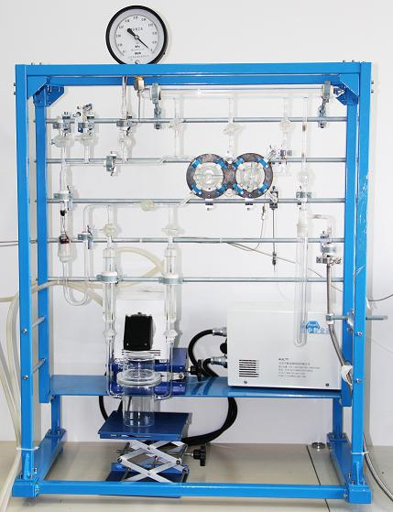
Figure S1

Figure S2

cubic phase
mixed phase
hexagonal phase
Figure S3

Figure S4

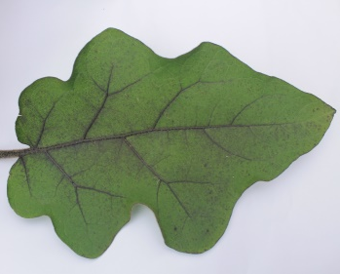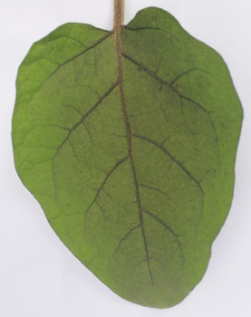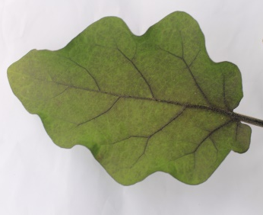
15.5 cm
8.3 cm
12.5 cm
7.8 cm
13.7 cm
9.0 cm
DEG-COSSM H₂O NH₄HCO₃
Eggplant
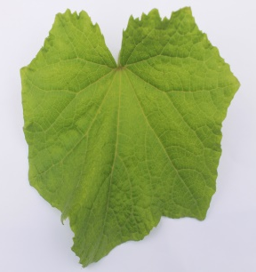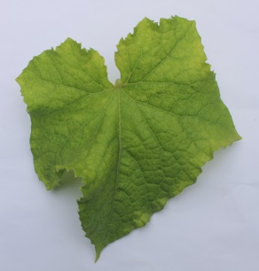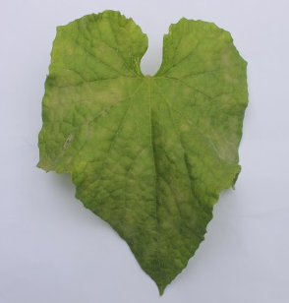
13.0 cm
8.0 cm
9.2 cm
8.0 cm
10.7 cm
10.5 cm
PPD-COSSM H₂O NH₄HCO₃
Cucumber
Figure S5
PEG 400-COSSM Water NH₄HCO₃ DEG-COSSM Water NH₄HCO₃
pepper eggplant
TeEG -COSSM Water NH₄HCO₃ TeEG-COSSM Water NH₄HCO₃
tomato cucumber
Figure S6

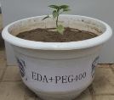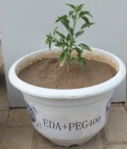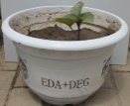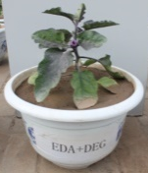
36.0 cm
41.7 cm
DEG-COSSM
PEG 400-COSSM
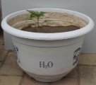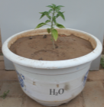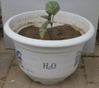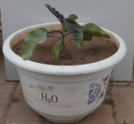
22.0 cm
24.0 cm
Water
Water
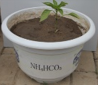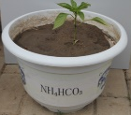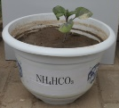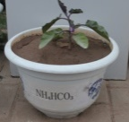
30.0 cm
23.5 cm
NH₄HCO₃
NH₄HCO₃
0 d 30 d 60 d 0 d 30 d 60 d
eggplant
pepper

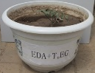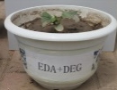
64.0 cm
117.0 cm
DEG-COSSM
TeEG-COSSM
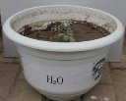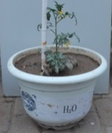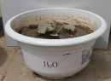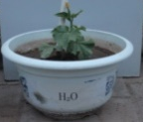
28.0 cm
49.0 cm
Water
Water
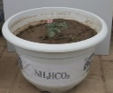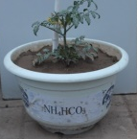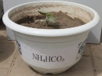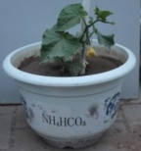
21.0 cm
55.0 cm
NH₄HCO₃
NH₄HCO₃
0 d 30 d 60 d 0 d 30 d 60 d
cucumber
tomato

Figure S7

