Electronic Supplementary Information (ESI-1)

Characterization of gel (After SDU dissolution in nitric acid)
The characterization of gel, prepared during dissolution of SDU in nitric acid has been carried out using Fourier Transformed Infrared (FTIR), Scanning Electron Microscope (SEM) with Energy Dispersive X-Ray Spectra (EDS) and Energy Dispersive x-ray fluorescent (EDXRF) techniques. Figure ESI-1 shows the FTIR Spectra of SDU and gel (Residue after dissolution in nitric acid). The peaks in SDU (solid line) at 1445.66 cm⁻¹, is because of C= O stretching frequency of carbonate group which is disappeared in gel (dotted line) due to decomposition of carbonate in to carbon di oxide in acidic medium. The new peak at 1074 cm⁻¹ in gel is matching with Si=O bond which indicate presence of silicon dioxide as silicate or polymer like silicones. Figure ESI-2 showed the Scanning Electron Microscopic images of SDU (a) and gel (b). Analysis of SEM images indicate that the SDU particle has flack like porous structures which become semi liquid containing particles in gel. The elemental analysis of SDU and gel Energy Dispersive X-Ray Spectra (EDS) indicate that the SDU contains uranium as major element (Figure ESI-3) where as in gel magnesium, iron silicon, and zirconium become major elements (Figure ESI-4). The EDXRF analysis of SDU powder and gel for U and Zirconium using standard less fundamental parameter (SLFP) techniques shows that the SDU powder contains only ~ 2% Zr where as in gel it become 40-55% as compared to uranium (Table ESI-1). Hence the results indicate that the gel contains Silicon, Zirconium and uranium as major element along with water, and nitric acid.

Figure ESI1-1: Comparison of FTIR spectra of SDU with residue after leaching with nitric acid

- (b)
Figure ESI1-2: Scanning electron Microscopic images of (a) SDU before leaching, (b) Residue after leaching

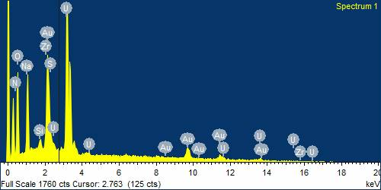
Figure ESI 1-3: Energy Dispersive X-Ray Spectra (EDS) of SDU

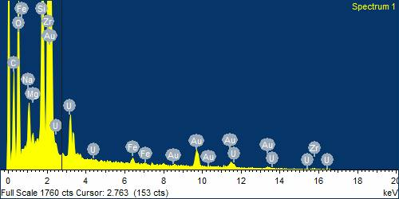

Figure ESI 1-4: Energy Dispersive X-Ray Spectra (EDS) of SDU of residue after leaching with nitric acid

EDXRF analysis of Gel for uranium and zirconium content

Table ESI-1: EDXRF analysis of Gel for uranium and zirconium content
Gel Sample | % U | % Zr
1 | 60.17 | 39.83
2 | 45.54 | 54.51
3 | 44.77 | 55.22
SDU powder | 97.81 | 2.18

